 | PSG CENTRE FOR ACADEMIC RESEARCH AND EXCELLENCE  One Year Certification Programme on Information Science  (2019-2020)  Organized by  Department of Information Technology  PSG College of Technology

COURSE OVERVIEW
In today’s IT Corporate environment, the applications are Complex, Scalable, Distributed and Mission-critical. They may be deployed on a variety of platforms across the corporate networks, Intranets, or Internet. Designing and developing such applications need to satisfy hundreds or thousands of separate functionalities.
This course emphasizes on imparting advanced conceptual knowledge, technical application skills and providing tailor-made solutions to ICT development and implementation. This innovative multi-disciplinary course integrates Communication, Computer and Information Technology to create solutions in diverse domains. This course provides a range of career opportunities in the IT industries as programmers, system analysts, network engineers and data communication specialists recruited in industries like Deshaw, Cisco, Microfocus, GE Digital, Oracle, Accenture, TCS, CTS, Robert bosch, etc.

COURSE OBJECTIVES
The objectives of this course
- Practice with an expertise in academics, design and development in computing technology
- Exhibit analytical, decision making and problem solving skills for handling real life problems with realistic constraints
- Ability to communicate the findings or express innovative ideas in an effective manner with an awareness of professional, social and ethical responsibilities

COURSE OUTCOMES
On completing the course, the participants will be able to

- Apply appropriate data structures to solve different real time problems
- Use contemporary database techniques and tools for developing projects
- Translate the requirements specification of the projects into an implementable design
- Apply appropriate big data analytics tools to process voluminous and scalable real time data
- Design and develop scalable virtual machines by analyzing various virtualization levels in cloud provisioning
- Develop smart real world projects using IoT protocols
- Apply an appropriate indexing methods in information retrieval Systems
- Solve an Industry related problems using latest techniques and technologies

MODE OF ASSESSMENT AND CERTIFICATION
The courses will be taught by experienced faculty members of the Department of Information Technology, PSG College of Technology. This course is conducted in Two Semesters which will comprise of theory, laboratory classes and a project work.
Assessment will be done for theory and laboratory courses (test, assignments and final examination) continuously and the performance in all such assessments will be considered for final grading. A final project viva will be conducted to evaluate the performance of the project work undertaken by the student.

ELIGIBILITY:
- B.Sc. / M.Sc. or Diploma/ B.E/ B. Tech or M.E /M. Tech
- Prerequisites of the Course: Basics knowledge in the field of Computer Science
SCHEDULE:
Classes will be conducted during second and fourth weekends of every month.

COURSE CO-ORDINATOR:
Dr. K. Umamaheswari, Professor and Head, Dept. of IT, PSG College of Technology
Dr.S.Sarathambekai, Programme coordinator, Dept. of IT, PSG College of Technology

SCHEME

SEMESTER I
CODE | SUBJECT | T | P | CA | FE | TOTAL
PGIT 01 01 | Algorithms and Analysis | 4 | 4 | 50 | 50 | 100
PGIT 01 02 | Database Technologies | 4 | - | 50 | 50 | 100
PGIT 01 03 | Software Engineering Methodologies | 4 | - | 50 | 50 | 100
PGIT 01 04 | Computer Communication Networks | 4 | - | 50 | 50 | 100
PGIT 01 05 | Application Development Laboratory | - | 4 | 50 | 50 | 100
 | TOTAL | 16* | 8* | 250 | 250 | 500

SEMESTER II
CODE | SUBJECT | T | P | CA | FE | TOTAL
PGIT 02 01 | Big Data Analytics | 4 | - | 50 | 50 | 100
PGIT 02 02 | Information Retrieval and Web Search | 4 | - | 50 | 50 | 100
PGIT 02 03 | Cloud Technologies | 4 | 2 | 50 | 50 | 100
PGIT 02 04 | Internet of Things | 4 | 2 | 50 | 50 | 100
PGIT 02 05 | Project Work | - | 4 | 50 | 50 | 100
 | TOTAL | 16* | 8* | 250 | 250 | 500

*Note: Specified hours indicate the total hours per month

Facilities Available

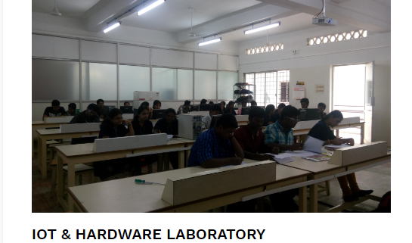
Using IoT laboratory, the students can do the projects related to IoT and Networks.

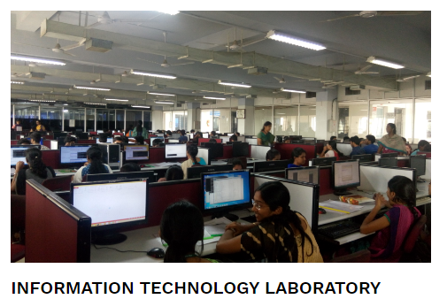

Using IT laboratory, the students can develop projects related to the domain Data mining, Big data and Database.

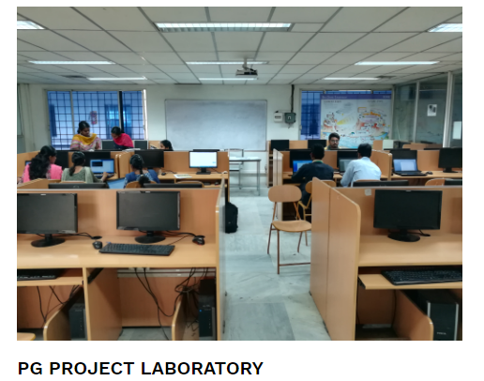

Cloud, Deep learning and AI related project can be developed by using PG project laboratory.

